Name: ________________________________________________ | Date completed: ______________________
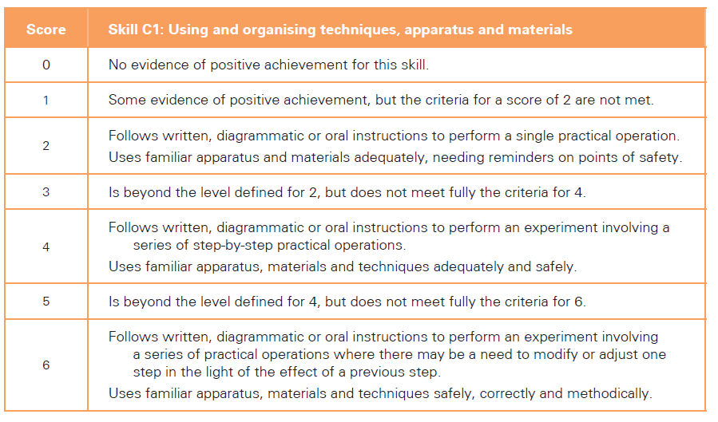 | 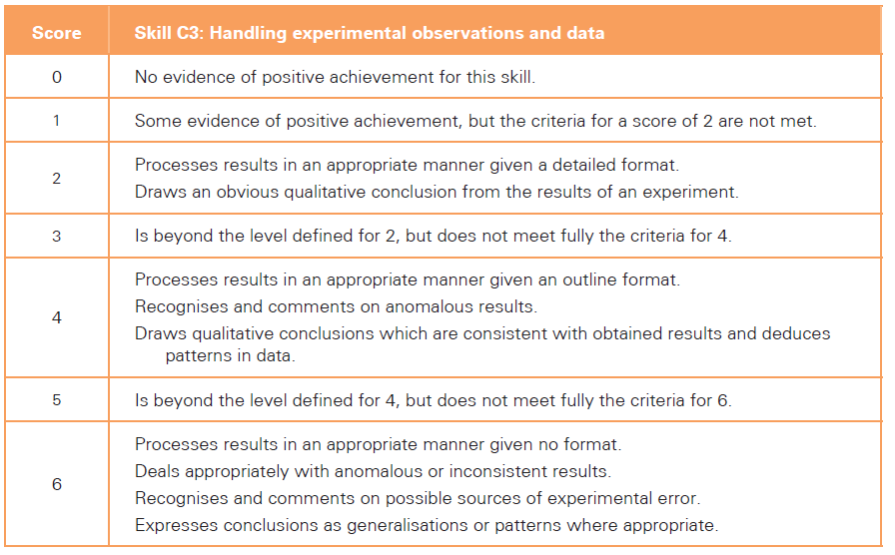
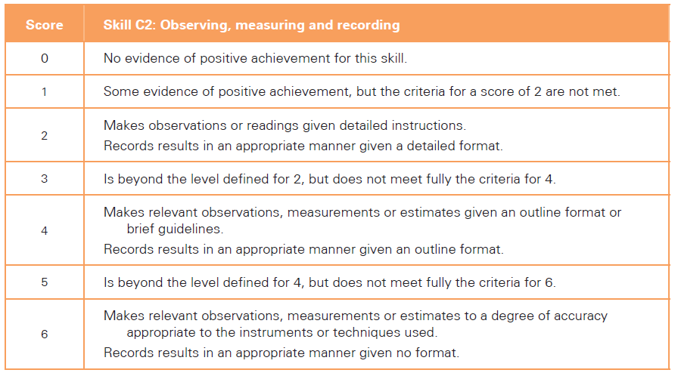 | 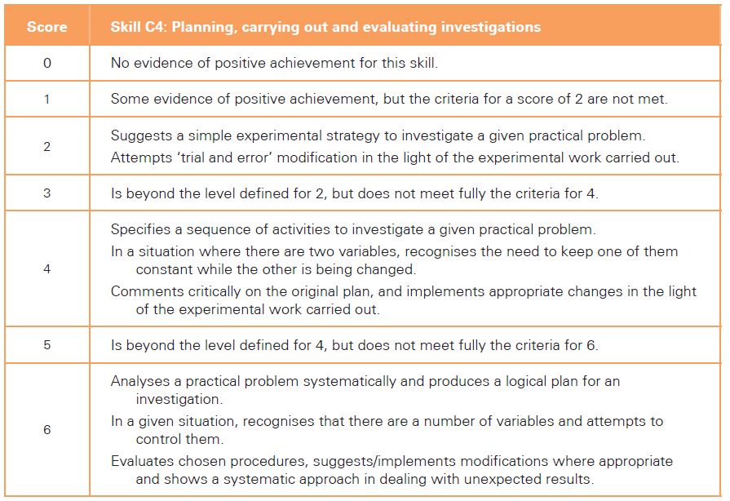
Effort: Total: ______/24 Grade: _______

Teacher comments:

How can I improve?

C1 Grade: ____/6 | C3 Grade: ____/6
C2 Grade: ____/6 | C4 Grade: ____/6

